**INDIVIDUAL ANALYSIS REPORT**

Group C1.04.05

07/03/2023

Author(s):

Carlos Bermejo Soria,[*carbersor@alum.us.es*](mailto:carbersor@alum.us.es)

**Table of contents**

**Table of contents** **2**

**1. Executive summary** **3**

**2. Revision table** **3**

**3. Introduction** **3**

**4. Contents** **3**

4.1. Performed tasks 3

4.2. Budget 4

**5. Conclusions** **4**

**6. Bibliography** **4**

1. **Executive summary**

This report summarizes the analysis needed for the second deliverable for Carlos Bermejo Soria’s work.

1. **Revision table**

| **No** | **Date** | **Description** |
| --- | --- | --- |
| 1.0 | 07/03/2023 | Initial draft of the document. |

1. **Introduction**

The analysis of the requirements is fundamental in every project to get the necessities of the customer right and understand the domain with precision. The documents provided to us already give a detailed expression of what the requirements might be and what they need to be completely fulfilled. If any of those requirements implores extra analysis it will be documented on these analysis reports throughout the different deliverables of the project.

1. **Contents**

This delivery required some analysis for the correct understanding of the requirements. Each of these decisions were taken having in mind the comments in the forum and the teacher’s advice.

**4.1. Requirements**

* **RI 05 (1).** I deduced from the text that every course has many lectures and lectures can exist by themselves, so the relation is not an aggregation even though the requirements use the word “aggregates”. That decision is for following the advices we were given in theory classes.
* **RI 05 (2).** Since a course is made by a specific lecturer (as deduced from the requirement regarding the lecturer dashboard, where it implicitly says that a lecturer needs data from his or her specific courses), there must exist a relation between both entities.
* **RI 05 (3).** According to the client, the nature attribute has to get 3 different specific values: Theoretical, Balanced and Hands-On; so it has to be an enumerate. The same applicates for the lectures.
* **RI 06 (1).** The estimated time could be represented in many different ways but I decided to follow the client’s recommendations and save it as a number where the integer part is the number of hours and it’s limited to 3 digits, and the decimal part is the percentage of an hour and it’s limited to 2 digits.

**4.2. Diagrams**

For this set of requirements I decided to make an individual UML model to represent each of the entities and classes needed for the deliverable, including their attributes, relations and restrictions.

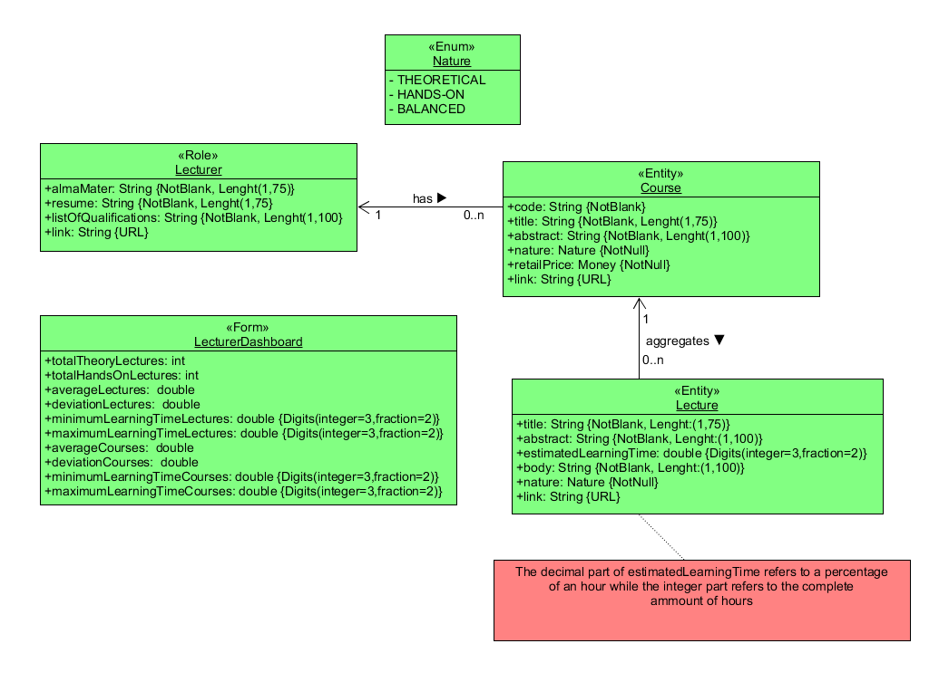

1. **Conclusions**

These were the overall details of the performed individual task by the member Carlos Bermejo Soria.

1. **Bibliography**

* Discussion board:

https://ev.us.es/webapps/discussionboard/do/forum?action=list_threads&course_id=_63009_1&nav=discussion_board&conf_id=_303964_1&forum_id=_206215_1